**Name of your game here**: Zombie Project

**Game Logo**



**Document Version Number (v0.1)**

**Author Name:** Conner, Matt, Shane, James,

**Introduction:**

You are a soldier abandoned on a military base in the middle of some ruins. Protect the communication equipment in a top down shooter from the waves of zombies until you are picked up by a helicopter.

**Genre**

Top down Tower Defence Shooting Game

**Theme**

Zombie, tower defence, post apocalyptic military

**Gameplay**

Player moves in a 360 degree scrolling screen within the 4 walls of the ruins. Player must destroy the waves of attacking zombies to defend the compound. Player can use a gun, grenades or traps to destroy enemies

**Reference to other games**

* Zombie Outbreak Arena - <https://www.youtube.com/watch?v=KxaRb3KCweQ>
* Yet another Zombie Defence HD - <https://www.youtube.com/watch?v=MFb6zgFpbYc>
* Enter the Gungeon

**Design Intentions**

* Real time action top down shooter
* Defending a pin point location is your main objective
* There is a period of time set aside for a “Build phase” where the player can easily build his defences
* Resource management
* Resources are gained at the start of each wave from a supply crate
* You can place traps, turrets, and barricades in dedicated positions
* Repairing mechanic. You can repair traps, barricades and turrets at the expense of time.
* Split between 2 modes. “Endless” where it never ends and ”Story” where you wait until evac
* You have a selection of weapons to attack the hoards of zombies.
* Infinite ammo, still have to reload

**Target Audience**

Target audience would be aimed at teenagers upwards. Level of violence might be a bit much for younger years. Older adults that enjoy retro old school shooters will enjoy the action in the games while today’s teenagers will love the Tower Defence style of game popular today.

**Game Atmosphere:**

• **Atmosphere mood**

It has the military theme thus military colours of khakis and light browns with the backdrop/skybox being the desert. Setting will be at night to enhance the fear factor of the zombie theme as the zombies will appear from the shadows to attack, there will be fog/fire particle effects..

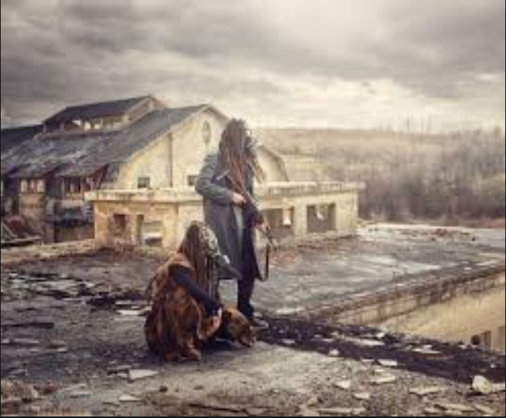

**• Location/level descriptions**

An overrun military base with a communications grid. The compound is surrounded by barren desert with broken down military vehicles and equipment. The walls of the compound are in various stages of decay with cracked broken walls. There is a radio room in the centre of the room which is the players lifeline and must be protected. Lying around on the compound floor are rusted ammo cases, barricades, oil drums and a well. There are ground turrets to protect the compound.

**• Character design**

Character design will be in 2d pixel art

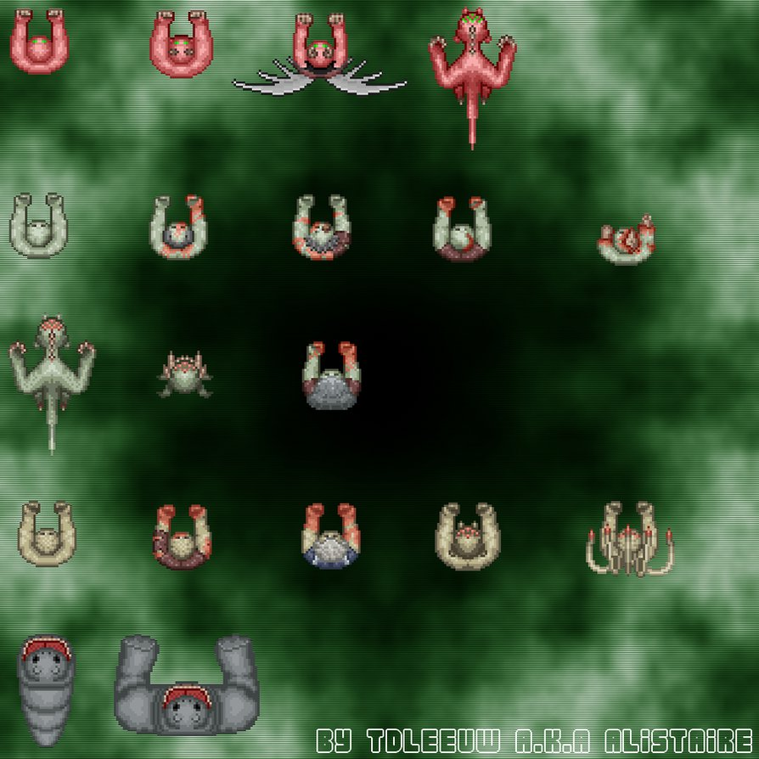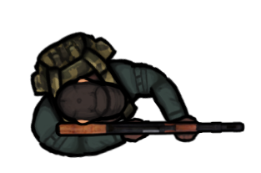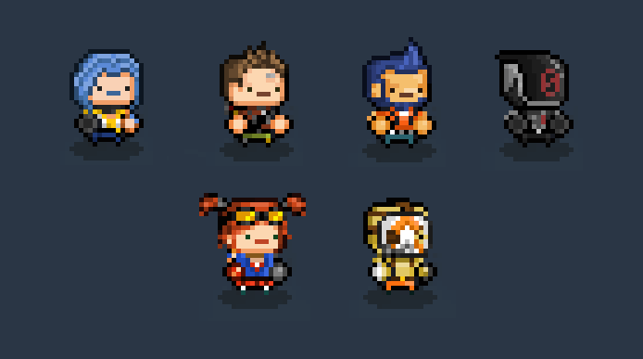

* **Art design and style**

The world will be 3 dimensional, while some things will be 2D sprites pointed at the camera (these being the player, the radio equipment, the evac helicopter (?), traps(?), turrets(?), weapons, and the enemies). The camera will be orthographic, pointed upwards on one axis. 3 dimensional objects will have pixel art textures.

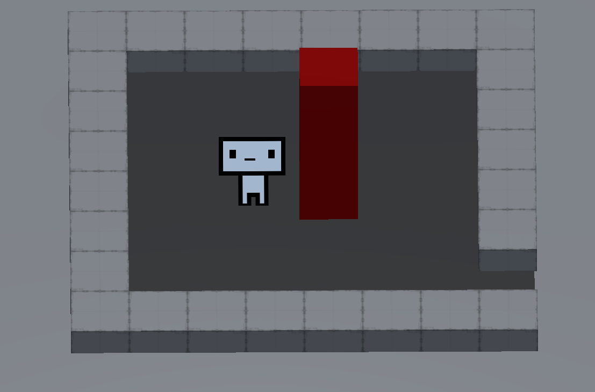

**Story:**

Communications have been lost with the ground zero military base from the resulting nuclear meltdown, you have been

tasked in retrieving vital information containing a vaccine for the viral outbreak and have been given x amount of time

to infiltrate the facility and recover the asset, Once the asset is recovered you need to communicate back to command for extraction.

But realising on arrival the broadcast tower is damaged and needs vital repairs!

**Scenario / setting**

• **Description**

Start: The story starts off your a lone soldier that has just been dropped off at the desert compound by helicopter to retrieve vital information, After retrieving this info you are to radio back but the broadcast tower to do so is down and needs repairs.

Middle: The player will find that they will start to quickly be swamped with zombie hoards and has to fortify his/her position whilst trying to repair the tower to radio for evac.

End: When the radio is repaired a helicopter appears and the player is flown away to safety. The helicopter unleashes firepower on the outpost killing any remaining zombiesai

**Gameplay:**

**Game Levels**

The game essentially has 1 level but consists of multiple rounds. A round consists of:

* Build - timed section for the player to place barricades, traps and turrets
* Gameplay - timed section where the player fights of the zombie hoards.

Each round consists of new weapons, traps, turrets and barricades (as outlined below) and increasing numbers of zombies

**Core Mechanics**

•**Player Controls**

* **WASD** to move the character around.
* The mouse cursor directs the fire trajectory.
* **Left mouse button** to fire.
* “R” key or press left click when gun is empty to reload.
* “1” switches to primary weapon
* “2” switches to secondary weapon
* “3” switches to wrench
* Build button **(tab?)** lets you scroll through current owned items **(1-9)** and place them with left click on a position.There are only a certain places the player can build things (ie turrets, traps and barricades on the ground). The item will build where the mouse cursor (left click) unless it isn’t an available build spot. If you have no items or have placed all of your items you can hit the “G”key to skip to the gameplay.

•**Game Elements**

This game will have a strategic element as the player will have to decide the best place to set up turrets/traps for defence to achieve the main goal of protecting the compound.

**Player Character**

* + **Health** -
* The player will have 100 health which can be depleted by zombie attacks or by stepping on a trap placed by the player.
* The player will have a average to fast health regeneration speed but will have a lengthy health regeneration pause where the player won’t regenerate health unless ‘x’ time has passed from the last time the player has taken damage.
* If player’s health reaches 0, game over
  + **Damage** -
* The player will damage the zombies by traps, turrets, and barricades or (optional) even the manned turret.
* The main way the player will be dealing damage is by shooting the zombies with a range of guns.
  + **Movement** -
* Movement will be average to fast to give the player a sense of speed to deal with the zombies as quickly as possible but also not too fast.

W - move up

A - move left

S - move right

D move right

No Key - player stops

* You cannot jump. Therefore the players main concern is to not get cornered. The sprite faces the direction of travel.
  + **Actions -**
* The player’s main objective is to protect the broadcast equipment.
* Player can shoot with guns by clicking left mouse button. Shooting direction will be in the direction of the mouse.
* Player can set up turrets, traps and barricades through the build menu.
* E to interact with the manned turret and to jump onto the helicopter at the end cutscene
* Hold E when highlighting a repairable item while selecting the repair tool to start the repair process, let go of E to cancel.
* Press E next to a door(doubles as a barricade) to open it.
  + **Spawning -** Player will spawn at the center of the compound on game start/or death.
  + **Anything Else**

**Zombies**

* + **Health -**
  + The zombies will have an average amount of health 20 health
  + Can be damaged through many means such as bullets, turrets, traps and barricades.
  + The zombies main advantage will be numbers rather than health.
  + When the zombies lose their health a small death animation play’s and the zombie becomes a corpse.
  + **Damage -**
  + The zombies will do a small to average amount of damage 10 damage to the player, turrets and the broadcast equipment.
  + They cause damage by hitting the thing they are attacking at a slow to average speed.
  + **Movement -** The zombies movement will be slow but not super slow otherwise it’ll get boring.
  + **AI -**
  + The zombies main objective is to go to the broadcast equipment but can move away from that objective when other objects comes into range of the zombie they can damage.
  + *Other objects being the player/turrets and barricades.*
  + Priority of attack (Low to high): broadcast equip < barricade < turret < player .
  + They will have a slow attack they do with a long cooldown.
  + While attacking they stay still
  + After attacking they remain still for a moment, then they resume walking.
  + **Actions -**
  + move to target (Player/Turret/Trap/Barricade)
  + attack/destroy object
  + DIE
  + **Spawning -**
  + They spawn in large groups in zombie spawn areas at the edge of the map.
  + A variable amount of groups of zombies spawn depending on the wave.
  + Spawning continues by randomly spawning groups for the duration of the timed round.
  + **Anything Else**

**HUD**

* General HUD (Both Phases)
  + The wave the player is currently on.
  + Player health.
  + Broadcasting equipment health.
  + Ammo in clip before reload
  + A health bar on objects that have taken damage will pop up when in range to be repaired
* Attack Phase HUD
  + The radio which will only pop up when the Broadcasting equipment is being damaged.
* Build Phase HUD
  + The amount of time left in build mode which will only be up when the player is in build mode.
  + The Build menu which will only come up when the build menu button is pressed (tab?) and will go away when it is pressed again. The menu shows what and how many traps, turrets and barricades the player has. It also shows which button to press to access them.
* **Sound**
* Background music - changes whether in attack mode or build mode
* gun fire sound
* Gun empty clip sound
* Scream/groan sound when contact with zombie
* Player hurt sound
* Mine explosion sound
* Bear trap sound
* Rc car moving sound
* Evac helicopter sound
* Radio sound when zombie attacks broadcast equipment
* ‘Splat’ sound when zombie destroyed
* Turret fire sound
* **Environment**

Playing area is large open space but still enclosed by partly ruined walls. The inside is mostly bare but contains mostly broken communication equipment, vehicles and some broken barracks etc

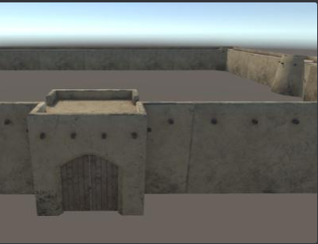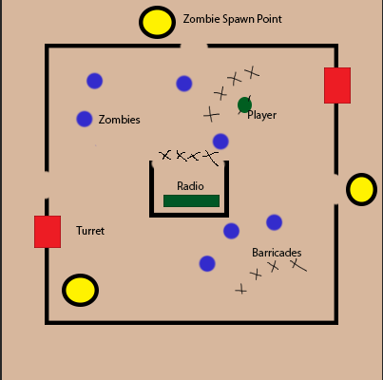

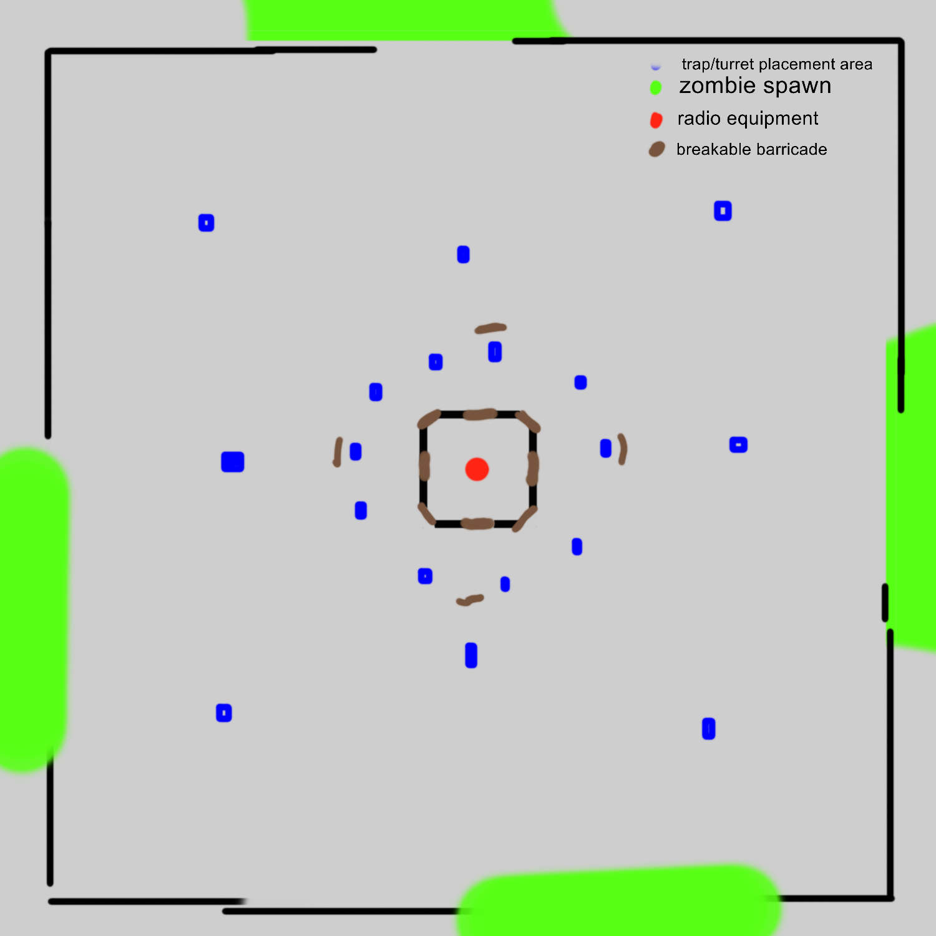

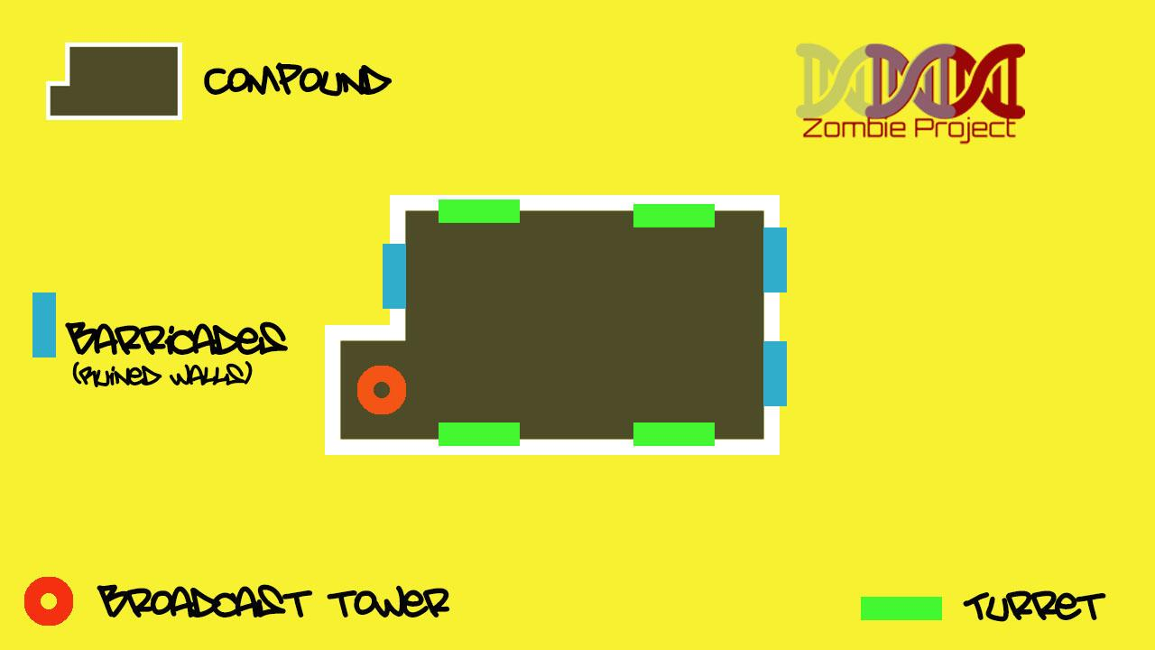

**Collisions**

* Zombie > Barricade : zombie destroyed, barricade loses health (2 hits to die)
* Zombie > Player : Player loses health. While zombie remains in contact with player - health is drained. This will take 5 seconds to deplete all of players health
* Zombie > Turret: turret destroyed
* Zombie > Gun Bullet: zombie loses health (dependant on gun), bullet destroyed
* Zombie > Trap: Slow zombie movement
* Zombie > Explosive Mine: All zombies within collision radius destroyed.
* Zombie > Radio Equipment: depletes health from the radio equipment.

**Build phase** -

* A phase where the player has time to build, however they can still build during attack mode but are more vulnerable.
* You have [30] seconds to repair objects, replace weapons (if wanted) and to place new objects in available build areas.
* Your repair skills and placement ability are faster in the build phase.
* Once the 30 seconds is over, an attack phase begins.
* *In this 30 second window a menu will pop up it will have Weapon loadouts/Defence and build menus, here the player will be able to swap there on person weapon.*

**Attack Phase** -

* This is when Build phase is over and the next wave has begun.
* The attack phase is where zombies move towards the objective.
* They spawn at random intervals from random positions.
* During the attack phase a piece of radio equipment is dropped. Player must collect and return it to the radio room. When this happens, all zombies die instantly. When the attack phase is over, the game returns to the build phase.

**Exit Phase (Helicopter) -**

Once the player has completed the game there will be a cutscene that the player can interact with. The cutscene will be the player running from a bunch of zombies to the helicopter. The player will just make it and has to jump on the helicopter. The interactive part could be shooting zombies getting close as the player runs and to hit the E button when they have to jump. This is a predetermined scene.

**Traps** -

* Traps are placed by the player in any available build areas.
* **Bear traps** -
  + The bear trap is triggered when a zombie steps on it,
  + The trap will kill the zombie instantly
  + The bear trap has limited uses before breaking and can be repaired
  + *Player must be in the radius of the trap and activate the repair.*
* **Explosive mines** -
  + The explosive mine activated when a zombie steps on or near it.
  + The explosion has splash damage causing damage to any nearby zombie’s too.
  + Does a large amount of damage.
  + Has to be repaired after one use.
  + *Player must be in the radius of the trap and activate the repair.*
* **(optional) rc car** -
  + The rc car is not stationary like the rest and will move in a direction making noise causing a distraction to the zombies and will cause them to follow it until it eventually explodes.
  + Average to large amount of damage and one use only.
  + Can’t be repairable since it activates as soon as the player places it.
  + It will be like a player controlled trap.
  + *The rc car can be selected when the player hits the C button and can place it in front of them. The rc car will continue to drive in a single direction until it eventually explodes.*

**Barricades** -

* The barricades are spikey and will kill a zombie if they run into it.
* If a zombie hits a barricade it deteriorates the barricade and loses hit points.
* If a second Zombie hits the barricade, the barricade is destroyed leaving a hole for zombies to swarm through.
* Barricades are placed by the player in the Build menu.
* In the first swarm the player can place “x” amount of barricades where they choose.
* The number of barricades increase with each round.
* Barricades will be placed on the ground in the level via the players build menu.

**Turrets**

* Shoots zombies when near.
* Turrets are placed by the player in available build areas.
* **Machine gun turrets** -
  + high fire rate
  + won’t need to reload or have ammo depletion.
  + can be destroyed by the zombies
  + can be repaired by the player.
  + Very small amount of damage each bullet (hense high fire rate).
  + The turret can rotate on its y axis and has a medium detection radius.
  + *When an enemy is detected it rotates to that direction and shoots until enemy leaves trigger box or is killed*
* **Javelin rocket turret** -
  + splash damage type turret which damages large amount of zombies.
  + medium fire rate
  + 2 shots before it needs to reload
  + The reloading is slow
  + doesn’t deplete in ammunition
  + can be destroyed or damaged by zombies
  + can be repaired by the player.
  + rotates and has a large detection radius.
  + *When an enemy is detected it rotates to that direction and shoots until enemy leaves trigger box or is killed*
* **(If we have time) Manned turret** -
  + A turret the player can use but also can’t cover the whole map with.
  + The Turret is predetermined and is already in the map,
  + The turret is a placed minigun
  + high fire rate
  + doesn’t need to be reloaded
  + can overheat which will leave it inoperable for a while (Overheating works based on the player holding the fire button too long).
  + It does more damage than the normal machine gun turret
  + can only work when the player controls it,
  + *the player only has to walk up to this manned turret and hit the E button to control it*.
  + It can’t be destroyed by the zombies.
  + It will have a 120 degree firing radius.

**Gun Operation / Ammo** -

* Guns will have unlimited ammo
* slight delay between shots.
* you have to reload after a number of shots which will leave the player temporarily vulnerable.
* Have to push the “R” key or press left click again to reload.
* Shooting is by left mouse click.
* *The player will be notified to reload via a small flashing ui text on the screen “Reload”*

**Guns** -

* + **Gun 1 (Round 1) - handgun** -
* takes 4 hits to kill a zombie
* Long delay between shots
* reload every 6 shots
* Medium range
* Regular speed bullet
  + **Gun 2 (Round 2) - .22 rifle** -
* 3 shots to kill a zombie
* Medium delay between shots
* reload every 10 shots
* Medium range
* Fastest speed bullet
  + **Gun 3 (Round 3) Semi Auto Rifle** -
* 3 hits
* Short delay between shots
* reload every 15 shots
* Medium range
* Faster speed bullet
  + **Gun 4 (round 4) High power rifle** -
* 2 hits to kill,
* very small delay between shots
* reload every 20 shots.
* Long range
* Fastest speed bullet
  + **Gun 5 Shotgun**
* 1 hit to kill,
* long delay between shots
* reload every shot
* Short Range
* Regular speed bullet

**Wrench-**

* Can be equipped instead of a weapon
* When held, health bar’s are shown above repairables
* When E is held next to a repairable its health bar gets filled (repair functionality already detailed in GDD)
* Left click activates a strong melee attack ([1] hit to kill) with a long delay between hits. This attack cannot be used while repairing. The range of the attack is a short distance in front of the player

**Projectiles**

* + **Turret bullets** -
* Bullets from the turrets which will go constantly go in a single direction until it collides with something.
* They fire in the direction of the closest zombie within the detection radius.
* It damages zombies
  + **Player gun bullets -**
* Bullets fired from the player’s gun.
* The delay between shots and damage done by the bullet is dependant on which gun it is fired from (see above)
* They will go in a constant direction which is towards where the players cursor is and will constantly move in that direction.
* They have a certain range.
* They will be destroyed when they collide with something or have been alive for x seconds.
* They damage zombies.
* Damage value is dependant on the gun

**Supply crate** -

* supply crate will supply the player with new guns as well as traps, barricades and turrets at the start of each round.
* There will be a spot that the player will always receive the supply drop and can be obtained when the player walks into it.
* The contents will be randomized
* >Quicker wave, more supplies< *probably a bad idea*
* Supply Crate will appear at the end of the round in designated spot.
* *Loot will be randomised by type each drop will have one or two items only Weapon/Turret/Barricade/Trap.*
* Broadcast equipment (one piece of equipment will drop in the middle of the round) as below.

**Broadcast equipment** -

* The broadcast equipment is the player’s main goal to protect
* if the equipment is destroyed then the player loses.
* The zombies will try to go after it as well as the player (could be making noise drawing their attention)
* The Broadcast equipment has health which is depleted when zombies attack it and when it is being attacked there is a loud high pitched static sound from the player’s radio which will also pop up on screen.
* The broadcast equipment is only to protect until evac arrives and has no other use.
* It can be repairable by the player however it is the longest thing to repair to the rest of the repairable things.
* Broadcast equipment (one piece of equipment will drop in the middle of the round)

**Winning / Losing**

* Losing if the player dies or the Broadcasting equipment is destroyed.
* The players goal is to survive until evac arrives.
* Once evac arrives the player wins and lives to fight another day.

**Why is this game fun?**

Strategic intensity causing the player the feeling that each decision could win or lose the game. There is constant action keeping the player intrigued and busy.

**Level Design:**

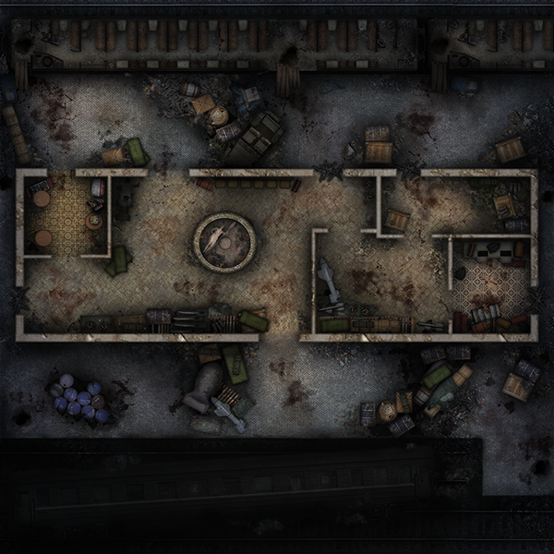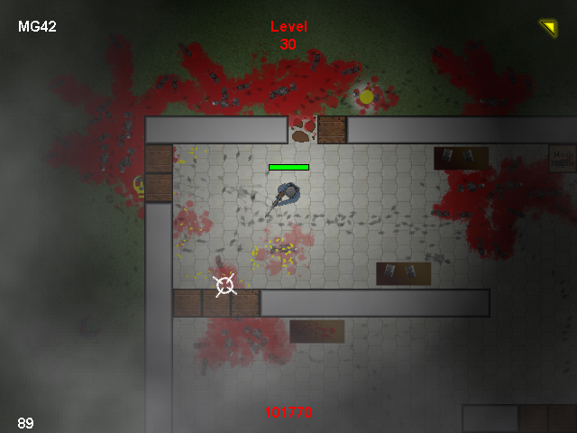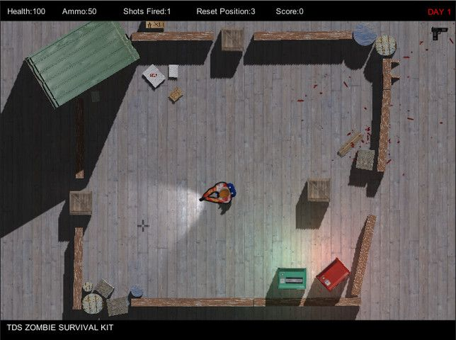

**How are your game levels constructed? Provide a rough physical layout of the game world showing you the different locations.**

Playing area is large open space but still enclosed by partly ruined walls. The inside is mostly bare but contains mostly broken communication equipment, vehicles and some broken barracks etc.



**Title and Information Screens:**

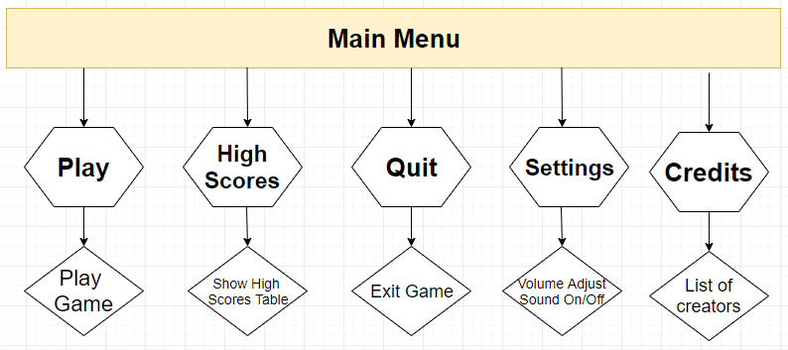

**Play - Story Mode**

**- Survival Mode**

**HighScores**

**Options - Sound Options**

**- Controls**

**Credits**

**Exit/Quit**

**Scope:**

Scope the size of your design - is it achievable or realistic within your time frame?

How much do you aim to include in the project?

Also include any information on plans for content updates later down the track.

Most of what we are doing is a part of the main game but we have left a few things as optional in case we don’t get to everything because the game will still be fun without them. The project itself however is at a medium level of difficulty and can be accomplished in the time frame. However this is our first game and if we run into any issues it may hinder our overall time to get it done by. So unless we have a lot of issues that take a while to fix we should have all the main stuff done in time.

**Feedback from Peers:**

* Add an introduction (elevator pitch)
* Add more detail into what rules and restrictions the game mechanics have.
* Add a player and zombie mechanics with sub mechanics of health and damage ect.
* Add some details about the environment and some examples.
* Add more on the player controls and what they do.
* Add what things in the game will be a 3D object or a 2D sprite
* Add a list of collisions and projectiles
* Think of the time period. E.g. futuristic military, modern military or post apocalyptic.
* Mention the attack phase and wave system
* Need more description for the atmosphere
* Properly explain the Location/level descriptions
* Maybe make the traps and turrets as 3D objects, idk experiment with it.
* Description and story beats should be added and have details about progress, start and end of story within game.
* Game levels, even if it’s one then just say it’s one. Say you might add more if you are
* Show a sign to the player on whether or not they have anything available
* What happens if the player’s health hits 0
* Player How do you move? W = up
* Player Actions. What do they do. E.g. Player can shoot
* How do zombies spawn
* What happens when a zombie dies
* Some more information about Zombie movement
* More specific about Zombie AI e.g player and turret and priority on what to chase first
* Actions the zombie can do e.g bite etc.
* Explain what happens when a zombie collides with a turret
* How do you reset the bear trap and how do you repair things and the collisions with it
* Explain how repairing works
* Explain rc car, how do you control it and how the player uses it
* Explain that the player places the barricades
* When and where and the limitations on how things are placed
* Remove re explained elements
* Decide how the turret is destroyed
* What does a turret do when it detects a target e.g rotates at ‘x’ speed and fires when target is directly or a cone radius in front
* Explain overheating work for manned turret
* How does player activate and control manned turret
* Let player know when they have to reload e.g sound effect of gun click
* Gun suggestion shotgun
* Damage value for the bullet itself. Modify the value from the gun it was fired from
* Supply crate. What will you randomise
* Supply crate might be bad and unbalanced for bad players. Change to a new weapon with advantages and disadvantages
* Other options that the broadcast equipment can do
* What is replacing weapons
* Use the same terminology
* Move phases as a primary mechanic area
* Put info from winning losing into player and zombie mechanic
* Add an options menu. Sound on/off and volume adjustment and credits
* Add a menu for changing game modes
* Don’t use a tool to repair. Just have the action repair it. But discuss it amongst yourselves

**Tasks to be completed for the creation of the game**

-Research of the Asset store for prefabs.

-Assign game production tasks to each student

-Setting up the trello document

**Sustainability Report**

**Estimated sustainability costs involved with the project**

As the project was conducted entirely online, the sustainability costs involved with the project were minimal as all resources were digital and there was no transport effects involved with travelling to a venue. The only real sustainability costs involved powering each group members’ computer. This cost is calculated below.

|  |  |  |  |  |
| --- | --- | --- | --- | --- |
| Group Member | 𝑃(𝑊)= 𝐼(𝐴)× 𝑉(𝑉)  P = Power in watts  I = Current in amps  V = Voltage in volts | 𝐸(kWh)= 𝑃(W)× 𝑡(hr) / 1000  *(number of hours - 20 lessons X 4 hrs + estimate of 5 hrs per week of own time = 140 hours)* | $ Cost per kWh  (as charged by electricity company) | Total cost per person |
| Shane | P(W) = 12.3 X 19.5  = 239.85 | E(kWh) = 239.85 X 140/1000  = 33.579 | 33.579 X $0.3834  = | $12.87 |
| James | P(W) = 11.8 X 19.5  = 230.1 | E(kWh) = 230.1 X 140/1000  = 32.214 | 32.214 X $0.25752  = | $8.30 |
| Matt | P(W) = 22.5 X 20  = 450 | E(kWh) = 450 X 140/1000  = 63 | 63 X $0.3995  = | $25.1685 |
| Connor | P(W) = 12.3 X 19  = 233.7 | E(kWh) = 233.7 X 140/1000  = 32.718 | 32.7 X 0.28  = | $9.15 |
| $ Total Cost |  |  |  | $55.49 |

**Plans to reduce resources used during development of the Game Project**

* Using online documents to prevent the use of paper and also as an added bonus allows for other people to quickly access or/and add
* Turn off computers when they are not in use. Unplug to save more power but may be a bit of a pain when returning to it regularly. So maybe before you go to bed. Put it into rest mode when leaving it short term.
* Trying to spread our game digitally to prevent the need to create physical products and create e-waste.
* activate the power management options of the operating system.